CSA1505 - CLOUD COMPUTING AND BIG DATA ANALYTICS
Experiment-5

5. Create a simple cloud software application for Mark Sheet Processing System using any Cloud Service Provider to demonstrate SaaS include the necessary fields such as name of the student, Reg no of the student , Subjects , Marks, Average, percentage, rank, overall performance etc.

AIM:
To develop a simple Mark Sheet Processing System using Zoho Creator (Cloud Service Provider) to demonstrate the Software as a Service (SaaS) model. The application manages student mark details, calculates the average, percentage, rank, and overall performance, and stores the results in a cloud-based environment.
PROCEDURE:
Log in to Zoho Creator.
Create a new application named Mark Sheet Processing System.
Design a form with the following fields:
- Student Name
- Register Number
- Subject 1
- Subject 2
- Subject 3
- Subject 4
- Subject 5
- Marks for each subject
- Total Marks
- Average
- Percentage
- Rank
- Overall Performance
- Result Date
Configure the required fields using text boxes, number fields, and calculated fields.
Create workflows to:
- Automatically calculate Total Marks.
- Calculate Average and Percentage.
- Display Overall Performance based on the percentage (Distinction, First Class, Second Class, Pass, or Fail).
- Automatically set the Result Date to the current date.
Save and publish the application.
Enter sample student details and marks, then submit the form.
Verify that the total, average, percentage, rank, and overall performance are calculated and stored correctly.

INPUT:
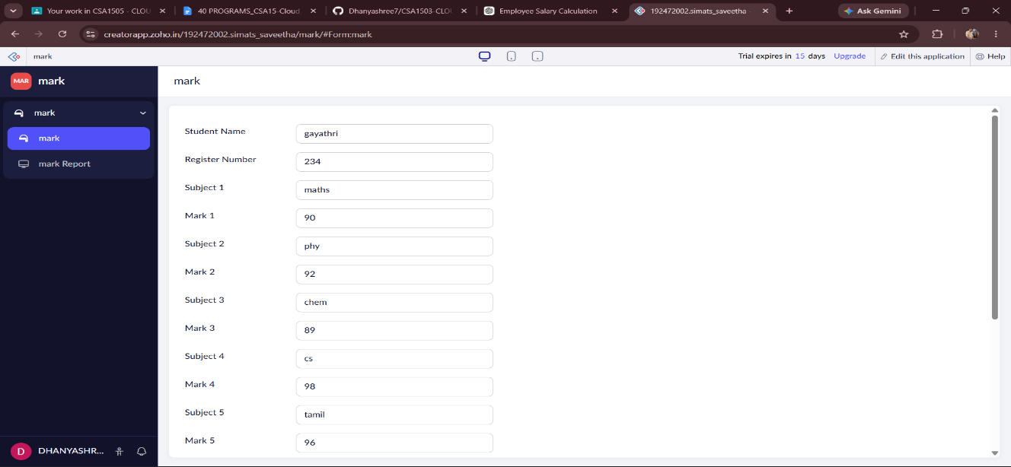
OUTPUT:
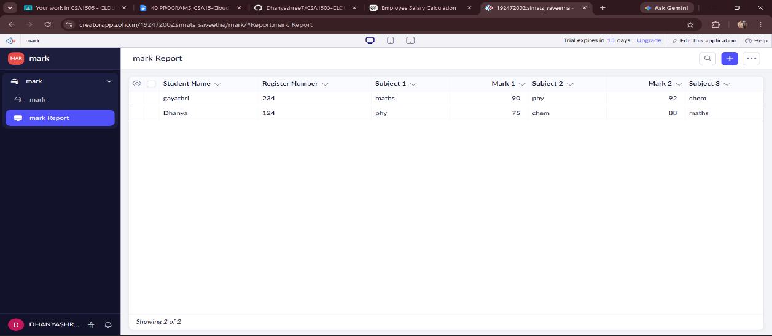
DESIGN:
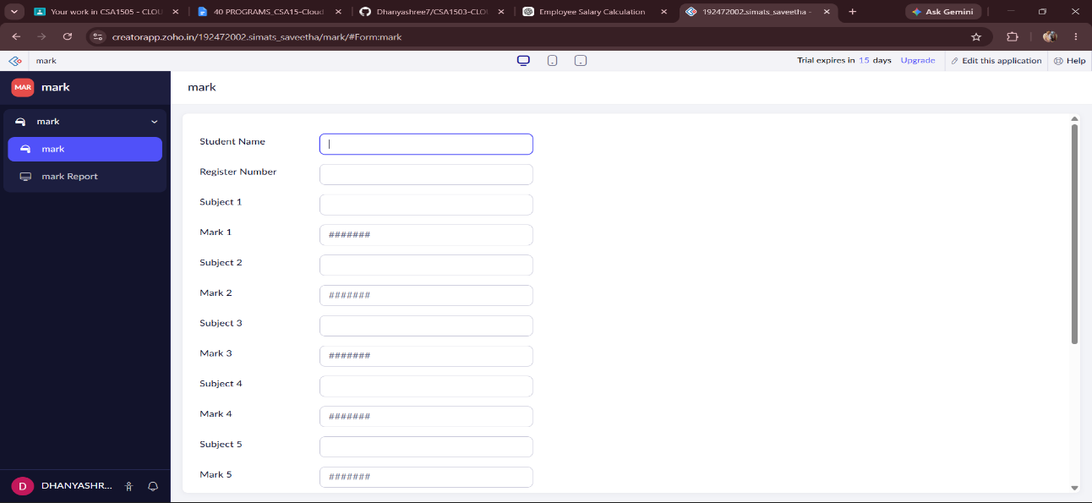

WORKFLOW:
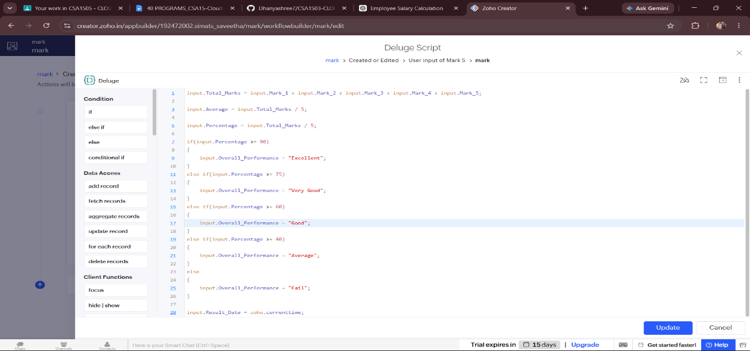

RESULT:
A cloud-based Mark Sheet Processing System was successfully developed using Zoho Creator. The application stores student information, automatically calculates the total marks, average, percentage, rank, and overall performance, and records the result date. This demonstrates the implementation of the Software as a Service (SaaS) model using a cloud platform.

